9. React-JS HOL

Name:- Shubham Sangram Bej

Hands-on 9

Objective
- Understand ES6 features in React.
- Implement the map() method to display collections.
- Use arrow functions for filtering data.
- Apply array destructuring.
- Merge arrays using the spread operator.
- Render components conditionally using a flag.

Software Requirements
- Node.js
- npm
- React
- Visual Studio Code

Project Name
cricketapp

Procedure
- Created a new React application named cricketapp.
- Created components:
  - ListofPlayers
  - Scorebelow70
  - IndianPlayers
  - ListofIndianPlayers
- Declared an array of eleven cricket players with their scores.
- Used the map() method to display all players.
- Used an arrow function with filter() to display players scoring less than or equal to 70.
- Applied array destructuring to separate odd and even team players.
- Merged T20 and Ranji Trophy player arrays using the spread operator (...).
- Used a flag variable with an if-else condition to switch between the two outputs.
- Executed the application using:
npm start
- Verified both outputs by changing the value of the flag variable.

Output
- When flag = true, the application displays the complete player list and players with scores less than or equal to 70.
- When flag = false, the application displays odd players, even players, and the merged Indian players list.
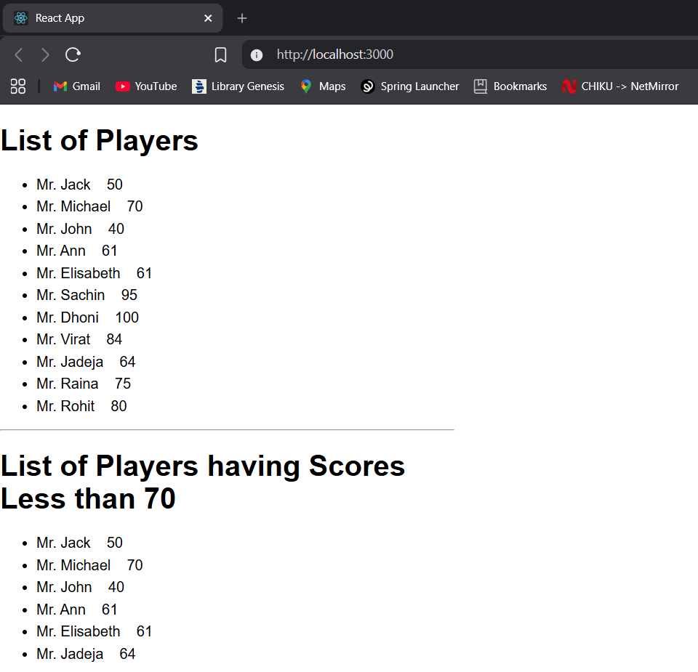
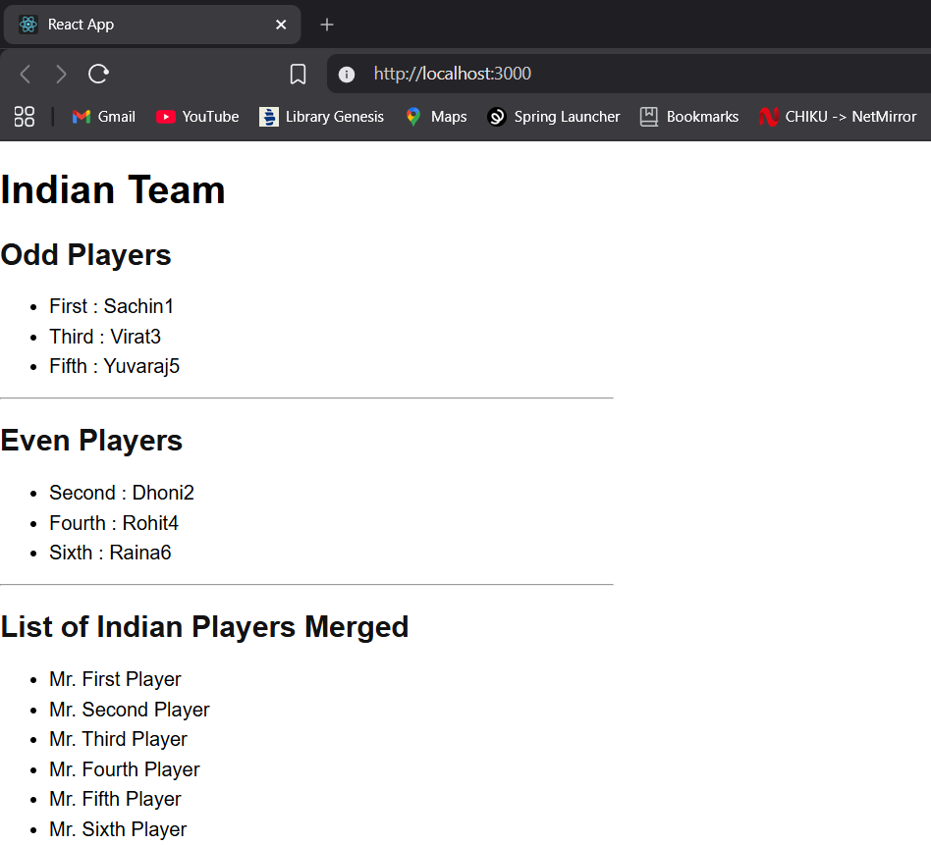

Result
The React application cricketapp was successfully implemented using ES6 features such as map(), arrow functions, destructuring, spread operator, and conditional rendering.

